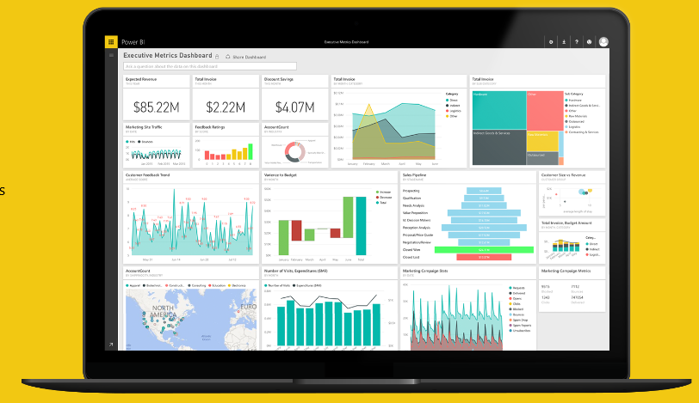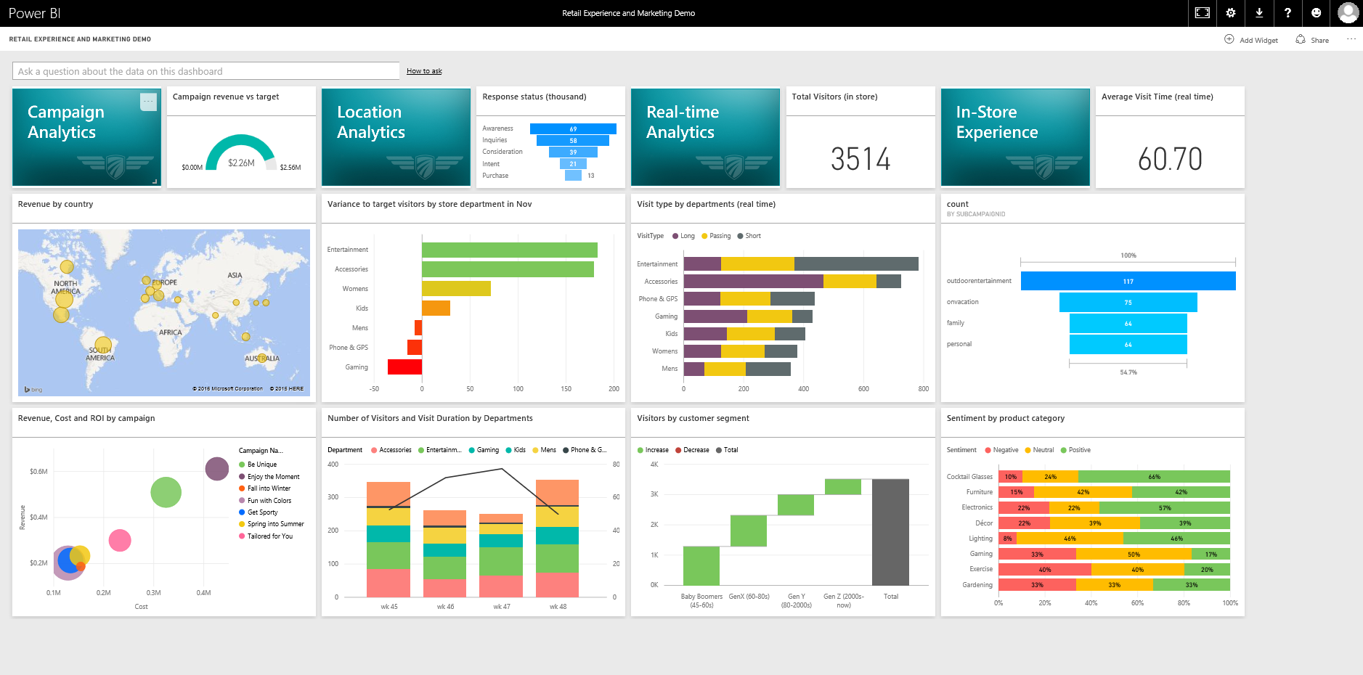

Setup Instructions:

**Preparing the Power BI Account for the Executive Summary Demo**

Start here to prepare your environment for the

**Executive Summary Demo**

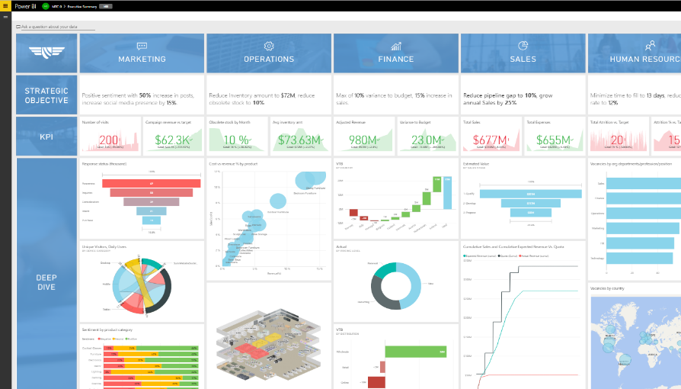

Published: November 2016

©2016 Microsoft Corporation. All rights reserved.

By using this demo/lab, you agree to the following terms:

The technology/functionality described in this demo/lab is provided by Microsoft Corporation for purposes of obtaining your feedback and to provide you with a learning experience. You may only use the demo/lab to evaluate such technology features and functionality and provide feedback to Microsoft. You may not use it for any other purpose. You may not modify, copy, distribute, transmit, display, perform, reproduce, publish, license, create derivative works from, transfer, or sell this demo/lab or any portion thereof.

COPYING OR REPRODUCTION OF THE DEMO/LAB (OR ANY PORTION OF IT) TO ANY OTHER SERVER OR LOCATION FOR FURTHER REPRODUCTION OR REDISTRIBUTION IS EXPRESSLY PROHIBITED.

THIS DEMO/LAB PROVIDES CERTAIN SOFTWARE TECHNOLOGY/PRODUCT FEATURES AND FUNCTIONALITY, INCLUDING POTENTIAL NEW FEATURES AND CONCEPTS, IN A SIMULATED ENVIRONMENT WITHOUT COMPLEX SET-UP OR INSTALLATION FOR THE PURPOSE DESCRIBED ABOVE. THE TECHNOLOGY/CONCEPTS REPRESENTED IN THIS DEMO/LAB MAY NOT REPRESENT FULL FEATURE FUNCTIONALITY AND MAY NOT WORK THE WAY A FINAL VERSION MAY WORK. WE ALSO MAY NOT RELEASE A FINAL VERSION OF SUCH FEATURES OR CONCEPTS. YOUR EXPERIENCE WITH USING SUCH FEATURES AND FUNCITONALITY IN A PHYSICAL ENVIRONMENT MAY ALSO BE DIFFERENT.

**FEEDBACK**. If you give feedback about the technology features, functionality and/or concepts described in this demo/lab to Microsoft, you give to Microsoft, without charge, the right to use, share and commercialize your feedback in any way and for any purpose. You also give to third parties, without charge, any patent rights needed for their products, technologies and services to use or interface with any specific parts of a Microsoft software or service that includes the feedback. You will not give feedback that is subject to a license that requires Microsoft to license its software or documentation to third parties because we include your feedback in them. These rights survive this agreement.

MICROSOFT CORPORATION HEREBY DISCLAIMS ALL WARRANTIES AND CONDITIONS WITH REGARD TO THE DEMO/LAB, INCLUDING ALL WARRANTIES AND CONDITIONS OF MERCHANTABILITY, WHETHER EXPRESS, IMPLIED OR STATUTORY, FITNESS FOR A PARTICULAR PURPOSE, TITLE AND NON-INFRINGEMENT. MICROSOFT DOES NOT MAKE ANY ASSURANCES OR REPRESENTATIONS WITH REGARD TO THE ACCURACY OF THE RESULTS, OUTPUT THAT DERIVES FROM USE OF DEMO/ LAB, OR SUITABILITY OF THE INFORMATION CONTAINED IN THE DEMO/LAB FOR ANY PURPOSE.

**DISCLAIMER**

This demo/lab contains only a portion of new features and enhancements in Microsoft Power BI. Some of the features might change in future releases of the product. In this demo/lab, you will learn about some, but not all, new features.

# Contents

Contents 3

About this demo 4

Goal 4

Prerequisites 4

Set up Power BI Account 5

Executive Summary Dashboard 5

Airline Dashboard 28

Power Apps setup 54

# About this demo

### Goal

The goal of this document is to help the reader to setup the necessary Power BI components for the Executive Summary and Airline Demo with Real-time sensor data set in Power BI Service.

### Prerequisites

This script has the following requirements:

* Power BI Account (Organizational accounts like @onmicrosoft.com, @microsoft.com)
* Power BI Desktop
* Azure Subscription
* Access to the Executive Summary demonstration assets.
  1. DeepDivePictures.pbix
  2. Exec Dashboard Marketing.pbix
  3. MTCFinance.pbix
  4. Exec Dashboard HR.pbix
  5. Exec Dashboard Operations.pbix
  6. Exec Dashboard Sales.pbix
  7. Exec Dashboard SalesJL.pbix
  8. Exec Dashboard Store Performance.pbix
* Streaming dataset worker role
  1. AirlineWorkerRole.cspkg
  2. ServiceConfiguration.Cloud.cscfg
* Access to the Executive Summary demonstration assets.
  1. MTC0drilldown.pbix
  2. MTC0Summary.pbix
  3. Logo.pbix
  4. RRBorders.pbix
* Power apps prerequisites
  1. Access to Office 365 account or subscription.
  2. Access to Power apps app downloaded from Windows Store.
  3. Access to Power Apps Airline app downloaded from Assets folder.

# Set up Power BI Account

## Executive Summary Dashboard

|  |  |
| --- | --- |
| **Step** | **Screenshot** |
| 1. Open browser (Edge), navigate to <http://app.powerbi.com>. **Sign in** with your Power BI account. If you don’t have an account, you can sign up for a free trial account. |  |
| 1. Expand the left navigation bar. 2. Expand My Workspace 3. Select **Create a group** |  |
| 1. Name your group: Executive summary 2. Choose privacy settings as per your requirement or keep it to default. 3. Add members to your group if required.      1. Save the group |  |
| 1. Add new Executive Summary dashboard to the Executive Summary group. |  |
| 1. Select **Get data** from left navigation. |  |
| 1. On the **Get Data** page, select the **Get** from **Files.** 2. On the **Files** page, select **Local File** and browse to the folder where you copied the PBIX file for this demo. 3. Go to the DeepDivePicture report. 4. Pin all the images to the Executive summary dashboard. |  |
| 1. Resize and rearrange the tiles as shown in figure. |  |
| 1. Let’s add objectives in the Strategic Objective section. 2. Select Add tile from the top right corner of the dashboard. |  |
| 1. In Add tile page select Text Box Then Click Next. |  |
| 1. For the Marketing section, copy and paste following tile content: Positive sentiment with **50%** increase in posts, increase social media presence by **15%**. 2. Then click Apply. Resize the tile to 1x2 size. 3. Apply same steps for other verticals   **Operations tile content:** Reduce Inventory amount to **$72M**, reduce obsolete stock to **10%**  **Finance tile content:**  Max of **10%** variance to budget, **15%** increase in sales.  **Sales tile content:**  Max of **10%** variance to budget, **15%** increase in sales.  **Human Resources tile content:**  Minimize time to fill to **13 days**, reduce attrition rate to **12%** |  |
| 1. Resize and rearrange tile as show in the screen. |  |
| 1. In the Power BI navigation pane on the left, select **Get Data**. 2. On the **Get Data** page, select the **Get** from **Files.** 3. On the **Files** page, select **Local File** and browse to the folder where you copied the PBIX file for this demo. 4. Select the Power BI Desktop file **Exec Dashboard Marketing.pbix**, then select **Open**.You will see the upload status.   Upload might take a few minutes based on file size, bandwidth and network connectivity.   1. Power BI adds the new dataset and report. Notice new items are marked with a yellow asterisk https://powerbi.uservoice.com/assets/82845592/PBI_YellowAsteriskSm.png 2. Click on the icon of the report you uploaded. 3. From **Campaign Analytics** report page, **select** and **pin** Campaign revenue vs target, Response status (thousand), Unique Visitors and Daily Users by Device Category visuals to the Executive Summary dashboard. |  |
| 1. Switch to Web & Social Analytics report page. |  |
| 1. From the **Web & Social Analytics** report page, **select** and **pin** Number of visits and Sentiment by product category visuals to the Executive Summary dashboard. |  |
| 1. Resize and rearrange tiles as show in figure. 2. This completes the Marketing section/vertical of the demo. |  |
| 1. In the next section we’ll complete **Operations** section of the dashboard. 2. In the Power BI navigation pane on the left, select **Get Data**. 3. On the **Get Data** page, select the **Get** from **Files.** 4. On the **Files** page, select **Local File** and browse to the folder where you copied the PBIX file for this demo. 5. Select the Power BI Desktop file **Exec Dashboard Operations.pbix**, then select **Open**.You will see the upload status.   Upload might take a few minutes based on file size, bandwidth and network connectivity   1. Power BI adds the new dataset and report. Notice new items are marked with a yellow asterisk https://powerbi.uservoice.com/assets/82845592/PBI_YellowAsteriskSm.png 2. Click on the icon of the report you uploaded. 3. From **Sales & Operations Planning** report page, **select** and **pin** Cost vs revenue % by product visual to the Executive Summary dashboard. |  |
| 1. Switch to the KPI report page. |  |
| 1. From **KPI** report page, **select** and **pin** Obsolete stock by Month and Avg inventory amt visual to the Executive Summary dashboard. |  |
| 1. **Resize** and **rearrange** tiles as show in figure   (KPI tile size 1x1, scatter chart tile size 3x2).   1. In the next section we’ll import store map to the Operations section of the dashboard. 2. Select **Get data** from left navigation. 3. In the Power BI navigation pane on the left, select **Get Data**. 4. On the **Get Data** page, select the **Get** from **Files.** 5. On the **Files** page, select **Local File** and browse to the folder where you copied the PBIX file for this demo. 6. Select the Power BI Desktop file **Exec Dashboard Store Performance.pbix**, then select **Open**.You will see the upload status.   Upload might take a few minutes based on file size, bandwidth and network connectivity   1. Power BI adds the new dataset and report. Notice new items are marked with a yellow asterisk https://powerbi.uservoice.com/assets/82845592/PBI_YellowAsteriskSm.png 2. Click on the icon of the report you uploaded. |  |
| 1. Switch to the Image report page of the **Exec Dashboard Store Performance** report. 2. **Pin** the Store map image to the Executive Summary dashboard. |  |
| 1. On the dashboard **resize** and **rearrange** tile as shown in figure (image tile size 3x2). 2. Go to the **Exec Dashboard Store Performance** report. Switch to the **Sales per sq. ft.** report page. 3. Then **copy the URL** from the address bar. 4. Go back to the dashboard. |  |
| 1. **Click** on… **Open menu** of the Store map image. |  |
| 1. In Tile details, **check** Display title and subtitle. 2. Enter **Title**: Sales per sq. ft. 3. **Check** Set custom link and in URL paste url of **Sales per sq. ft.** report page (copied in the step 57 above) 4. Then choose **Yes** to open custom link in the same tab. 5. Select **Apply**. 6. This completes the Operations section/vertical of the demo. |  |
| 1. In the next section we’ll complete **Finance** section of the dashboard. 2. In the Power BI navigation pane on the left, select **Get Data**. 3. On the **Get Data** page, select the **Get** from **Files.** 4. On the **Files** page, select **Local File** and browse to the folder where you copied the PBIX file for this demo. 5. Select the Power BI Desktop file **MTCFinance.pbix**, then select **Open**.You will see the upload status.   Upload might take a few minutes based on file size, bandwidth and network connectivity.   1. Power BI adds the new dataset and report. Notice new items are marked with a yellow asterisk https://powerbi.uservoice.com/assets/82845592/PBI_YellowAsteriskSm.png 2. Click on the icon of the report you uploaded. 3. From **Revenue Report** page, **select** and **pin** Actual Revenue, Variance to Budget, VTB by Country and VTB by Distribution visuals to the Executive Summary dashboard. |  |
| 1. Switch to Pricing Level report page. 2. **Pin** the Pie chart to the Executive Summary dashboard. |  |
| 1. Go back to the dashboard. 2. On the dashboard **resize** and **rearrange** tiles as shown in figure (KPI tiles size 1x1, Waterfall chart tile size 2x2, Pie chart tile size 2x2, Bar chart tile size 2x2). 3. This completes the **Finance** section/vertical of the demo. |  |
| 1. In the next section we’ll complete **Sales** section of the dashboard. 2. In the Power BI navigation pane on the left, select **Get Data**. 3. On the **Get Data** page, select the **Get** from **Files.** 4. On the **Files** page, select **Local File** and browse to the folder where you copied the PBIX file for this demo. 5. Select the Power BI Desktop file **Exec Dashboard Sales.pbix**, then select **Open**.You will see the upload status.   Upload might take a few minutes based on file size, bandwidth and network connectivity.   1. Power BI adds the new dataset and report. Notice new items are marked with a yellow asterisk https://powerbi.uservoice.com/assets/82845592/PBI_YellowAsteriskSm.png 2. Click on the icon of the report you uploaded. 3. From **Pipeline** report page, **select** and **pin** ‘Cumulative Sales and Cumulative Expected Revenue Vs. Quota’ and ‘Estimated Value by Sales Stage’ visuals to the Executive Summary dashboard. |  |
| 1. In the Power BI navigation pane on the left, select **Get Data**. 2. On the **Get Data** page, select the **Get** from **Files.** 3. On the **Files** page, select **Local File** and browse to the folder where you copied the PBIX file for this demo. 4. Select the Power BI Desktop file **Exec Dashboard SalesJL.pbix**, then select **Open**.You will see the upload status.   Upload might take a few minutes based on file size, bandwidth and network connectivity.   1. Power BI adds the new dataset and report. Notice new items are marked with a yellow asterisk https://powerbi.uservoice.com/assets/82845592/PBI_YellowAsteriskSm.png 2. Click on the icon of the report you uploaded. 3. From **Revenue & Profitability Management** report page, **select** and **pin** ‘Total Revenue’ and ‘Total Expenses’ visuals to the Executive Summary dashboard. |  |
| 1. Resize and rearrange tiles as show in figure.   (KPI tile size 1x1, Funnel chart 2x2, Line chart tile size 3x2).   1. **Click** on **Funnel chart**, copy the URL from the address bar. |  |
| 1. Edit Total Revenue tile details. |  |
| 1. Check **Set custom link** and in URL paste url of Sales per sq. ft. report page (copied in the step 95 above) 2. Then choose No to open custom link in the same tab. 3. Select **Apply**. 4. Repeat same steps for **Total Expenses** tile. 5. This completes the **Sales** section/vertical of the demo. |  |
| 1. In the next section we’ll complete human resources section of the dashboard. 2. In the Power BI navigation pane on the left, select **Get Data**. 3. On the **Get Data** page, select the **Get** from **Files.** 4. On the **Files** page, select **Local File** and browse to the folder where you copied the PBIX file for this demo. 5. Select the Power BI Desktop file **Exec Dashboard HR.pbix**, then select **Open**.You will see the upload status. 6. Power BI adds the new dataset and report. Notice new items are marked with a yellow asterisk https://powerbi.uservoice.com/assets/82845592/PBI_YellowAsteriskSm.png 7. Click on the icon of the report you uploaded. 8. From **Demand Planning** report page, **select** and **pin** Vacancies by org departments/profession/position, Vacancies by country visual to the Executive Summary dashboard. |  |
| 1. Switch to Retention & Recruiting tab of the report. |  |
| 1. From **Retention & Recruiting** report page, **select** and **pin** KPI visuals to the Executive Summary dashboard. |  |
| 1. **Resize** and **rearrange** tiles as show in figure.   (KPI tile size 1x1, Bar chart tile size 3x2, Map tile size 3x2)   1. This completes the HR section/vertical of the demo. |  |

## Airline Dashboard

| **Airline Dashboard setup** | |
| --- | --- |
| **Steps** | **Screeshot** |
| 1. Go to the **Executive Summary** Workspace. 2. **Create** a new dashboard by clicking on **+** sign next to the dashboards. 3. Name the new dashboard as “**Airline**” |  |
| 1. **Select** **Get data** from left navigation. 2. **Select** Get under Import or connect to data to import **Files**. 3. Select on **Local file** to import and browse to the folder where you copied the PBIX file for this demo. 4. **Choose** MTC0drilldown.pbix file and import the file to Power BI Service.   Upload might take a few minutes based on file size, bandwidth and network connectivity.   1. Similarly upload following pbix files.    1. Logo.pbix    2. RRBorders.pbix |  |
| 1. Navigate to **RRBorders_MTC0** report imported earlier into Power BI Service. 2. Go to **Fleet summary and Real-time analytics page** and pin Fleet summary Image to Airline dashboard. |  |
| 1. Go to **Engine Diagnostic Page** and pin Engine Diagnostic tile to the Airline dashboard |  |
| 1. Go to **Fleet summary and Real-time analytics page** and pin Real-time analytics tile to the Airline dashboard. |  |
| 1. **Resize** and **re-arrange** tiles on the dashboard as shown in the Screenshot. |  |
| 1. Go to **Logo report** and pin the visual to the Airline dashboard |  |
| 1. Go to **MTC0Drilldown report** and go to Anomaly detection page and pin Confidence in prediction Gauge chart to the Airline dashboard. 2. Pin **Current AUC** Card to the Airline Dashboard. 3. Pin **Determination by Feature & Rank** column chart to the Airline Dashboard. |  |
| 1. Similarly, Pin **Sensor 17** Area chart to the Airline Dashboard. |  |
| 1. From Address bar **copy URL** of the MTC0drilldown report. |  |
| 1. **Open** MTC0Summary.pbix in Power BI Desktop. 2. **Click** Edit Queries. This opens Query Editor. |  |
| 1. From Queries Section **Select** CurrentIssues2 query. |  |
| 1. In Query Settings section, **Select** Replaced Value step, then **Click**  to edit the values. This opens Replace Value window. |  |
| 1. In Replace With text box **paste URL** of MTC0drilldown report (copied above). **Click** OK. 2. **Repeat** for Replaced Value1 to Replaced Value5. |  |
| 1. **Click** Close & Apply. 2. **Save** the file. |  |
| 1. **Switch** to browser **Go** to the Power BI Service. 2. **Select** **Get data** from left navigation. 3. **Select** Get under Import or connect to data to import **Files**. 4. Select on **Local file** to import and browse to the folder where you copied the PBIX file for this demo. 5. **Choose** MTC0drilldown.pbix file and import the file to Power BI Service.   Upload might take a few minutes based on file size, bandwidth and network connectivity. |  |
| 1. Go to **MTC0Summary report** and navigate to **Fleet policies page** pin **Fleet policy comparison column chart**. 2. Rename the tilt of the column chart to ***Performance v Budget*** by clicking on Pen icon on the tile. |  |
| 1. Go to **MTC0Summary report** and navigate to **Fleet Policies page** pin **Policy Impact Breakdown** bar chartto the Airline dashboard. 2. Rename the tile of the bar chart to ***Key Performance Indicators.*** |  |
| 1. Go to **MTC0Summary** **report** and Go to **Fleet summary** page 2. **Pin** the custom visual **Flight schedule** to the Airline dashboard. 3. **Rename** the visual to ***Current fleet schedule*** by clicking on the pen icon on the tile after it is pinned to the dashboard. |  |
| 1. **Pin** the map visual **Current Location or Next Location** to the Airline dashboard. 2. **Rename** the map visual to ***Fleet summary map.*** |  |
| 1. Go to **MTC0Summary** **report** and go to **Engine Diagnostics page** and Pin **Engine Party by Faults** bar chart to the Airline dashboard. 2. **Rename** the tile of the pinned bar chart to ***Faults by Engine parts***. |  |
| 1. Go to **MTC0Summary** **report** and go to **Engine Diagnostics** page and Pin Turbine Engine (Lateral) chart to the Airline Dashboard. 2. **Rename** the chart to *Faults by Engine Parts* |  |
| 1. Resize and re-arrange tiles on the dashboard as shown in the Screenshot. |  |

|  |  |
| --- | --- |
| **Set up a streaming dataset in Power BI Account** | |
| **Steps** | **Screenshot** |
| 1. **Switch** to <http://app.powerbi.com> then Go to Executive Summary workspace. 2. **Expand** the left navigation bar. 3. **Go to** Streaming Datasets, at the very bottom of the left navigation bar. |  |
| 1. "**Add** streaming datasets" in the top right. |  |
| 1. In “New streaming dataset”, Choose API as the source of your data. 2. Then **Click** Next |  |
| 1. **Enter** a Dataset name: Engine data 2. In values from stream, enter "timestamp" of type "DateTime" 3. In values from stream, enter "number" of type "Number" 4. **Check** the "Historic data analysis" 5. **Click** "Create" |  |
| 1. In the next page, **copy** the "Push URL". 2. **Copy** Push URL in notepad or OneNote for future use. 3. **Click** “Done” |  |

|  |  |
| --- | --- |
| **Prepare the Azure for the Airline demo streaming dataset** | |
| **Step** | **Screenshot** |
| 1. These setup steps are necessary for Setting up streaming dataset in Azure environment. In this section we’ll deploy cloud service worker role to the Azure. 2. **Open** ServiceConfiguration.Cloud.cscfg file in notepad (accompanied with this package). 3. **Edit** the Rest_Api_EndPoint settings value, use the Push URL created in the section above. |  |
| 1. **Log in** to the Azure portal. 2. **Click** New > Virtual Machines, and then scroll down to and **Select** Cloud Service. 3. At the bottom of the information page that displays, **click** Create. | D:\Projects\PBI_MTC\images\create-cloud-service.png |
| 1. In the new Cloud Service blade, enter a value for the DNS name. 2. Create a new Resource Group or select an existing one (Choose based on how you maintain your Azure Subscription). 3. Select a Location. 4. **Click** Package. This will open the Upload a package blade. Fill in the required fields. 5. Select Storage account or create new storage account and select it (Choose based on how you maintain your Azure Subscription). 6. Enter a value for Deployment label “airline-realtime-worker-role” 7. To upload package, click on the folder icon in Package, it will open file browse window, select “AirlineWorkerRole.cspkg” file. 8. To upload worker role configuration, click on folder icon in Configuration, select file named “ServiceConfiguration.Cloud.cscfg” 9. **Select** Production in environment settings. 10. Make sure that Start deployment is **Checked**. 11. **Click** OK which will close the Upload a package blade. 12. **Click** Create. |  |

|  |  |
| --- | --- |
| **Create Visuals for Streaming dataset in Power BI** | |
| **Demo step** | **Screenshot** |
| 1. Go to the Airline dashboard. |  |
| 1. **Click** the "Add tile" button in the top right |  |
| 1. **Select** "custom streaming data". |  |
| 1. **Select** the dataset: Engine data that you created in section “Set up a streaming dataset in Power BI Account”. 2. **Click** Next. |  |
| 1. **Create** a real-time line chart 2. **Select** "Line chart" under Visualization Type. 3. Under Axis, **Select** "timestamp". 4. Under "Values", **Select** "number". 5. **Click** Next. 6. The streaming tile should now appear on your dashboard, and be updating in real-time. |  |
| 1. In Tile details **add title**: “Live update of key sensor”. 2. **Click** Apply. |  |

|  |  |
| --- | --- |
| **Create a report, tile that updates in real-time** | |
| **Steps** | **Screenshot** |
| 1. Go to streaming datasets in the left navigation bar. |  |
| 1. **Find** the row corresponding to the **Engine data** dataset that you created in the section ”Set up a streaming dataset in Power BI Account”, and select the "Create Report" button. |  |
| 1. In the new report, **create** a line chart for the data   a. Select the line chart visual  b. Drag timestamp to the "Axis" field  c. Drag number to the "Values" field  d. Make any further adjustments to the report visual   1. **Save** the Report. 2. **Pin** the visual to the dashboard. |  |
| 1. **Resize** and **re-arrange** tiles on the dashboard as shown in the Screenshot.   End of setup. |  |

|  |  |
| --- | --- |
| **Clear Data Tables(Optional)** | |
| **Steps** | **Screenshot** |
| 1. This section is optional may require while redoing setup or during Real-time dataset cleanup activity. 2. Visit URL:   <https://www.neudesic.com/resources/blog/business-intelligence-big-data/clear-data-tables-fast/>   1. Scroll down for instructions. To open the tool, click on the URL **The** **Tool – PBI API Tools.** |  |
| 1. Login to your Power BI account in which you want to clear rows in the dataset. |  |
| 1. Accept the terms. |  |
| 1. Click on **Get Groups** to gets a list of groups associated with your Power BI account and populates the groups drop down list.   Select a group “**Executive Summary**”. |  |
| 1. Click on **Get Datasets** to gets a list of datasets associated with your Power BI account or the selected group and populates the datasets drop down list. 2. **Select** *Engine Data* dataset. |  |
| 1. Click on **Get Tables** to gets a list of tables associated with selected dataset and populates the tables drop down list. 2. **Select** *RealTimeData* table to continue. 3. Click on the **Clear Table** to clear rows from the selected table. |  |

# Power Apps setup

| **Steps** | **Screenshots** |
| --- | --- |
| 1. Download **Airline Engine Inspection.msapp** file to the local machine from the assets folder provided. |  |
| 1. Navigate to **Powerapps studio** on windows machine. |  |
| 1. Login with **Office 365** account. 2. Click on **Browse** on the top right hand corner. 3. Select the Airline **Engine Inspection.msapp** file downloaded earlier. |  |
| 1. Check if the file uploaded correctly with all **tiles** with phone layout. |  |
| 1. Click on **Save** on the left Navigation pane and Select **Save as** then **Select The Cloud** option. 2. Click on **Save**. |  |
| 1. Navigate to [www.powerapps.microsoft.com](http://www.powerapps.microsoft.com) website to check if the application is saved correctly to the cloud and ready to use. 2. Login to [www.powerapps.microsoft.com](http://www.powerapps.microsoft.com) with the same office 365 account used earlier. 3. Click on **Airline Engine Inspection application**. |  |
| 1. Click on Allow to give access to **Camera** by the power apps application. |  |
| 1. Airline Engine Inspection Power apps application is successfully setup on the **Power apps** website and ready to use for demo. 2. End of Power Apps setup document. |  |